**Practical File**

**Of**

**Operating System**

**22CS005**

***Submitted***

***in partial fulfillment for the award of the degree***

# of

**BACHELEOR OF ENGINEERING**

***in***

COMPUTER SCIENCE & ENGINEERING



**CHITKARA UNIVERSITY**

**CHANDIGARH-PATIALA NATIONAL HIGHWAY**

**RAJPURA (PATIALA) PUNJAB-140401 (INDIA)**

June, 2024

**Submitted To: Submitted By:**

Dr. Ravneet Kaur Komal

Assistant Professor 2310991738

Chitkara University, Punjab 2nd Sem. - Batch 2023

# INDEX

|  |  |  |
| --- | --- | --- |
| **Sr.**  **No.** | **Practical Name** | **Teacher Sign** |
| 1 | 1. Installation: Configuration & Customizations of Linux 2. Introduction to GCC compiler: Basics of GCC, Compilation of program, Execution of program. 3. Time stamping in Linux. 4. Automating the execution using Make file. |  |
| 2 | Implement the basic and user status commands like: su, sudo, man, help, history, who, whoami, id, uname, uptime, free, tty, cal, date, hostname, reboot, clear |  |
| 3 | Implement the commands that is used for Creating and Manipulating files: cat, cp, mv, rm, ls and its options, touch and their options, which is, where is, what is |  |
| 4 | Implement Directory oriented commands: cd, pwd, mkdir, rmdir, Comparing Files using diff, cmp, comm. |  |
| 5 | Write a program and execute the same to demonstrate how to use terminal commands in C program (using system() function) |  |
| 6 | Write a program to implement process concepts using C language by printing process Id. |  |
| 7 | Write a program to create and execute process using fork() and exec() system calls. |  |
| 8 | Write a C program to implement FCFS (First Come First Serve) and SJF (Shortest Job First) scheduling algorithms. |  |
| 9 | Write a C program to implement Priority Scheduling and RR (RoundRobin) scheduling algorithms. |  |

**Program 1:** a) Installation: Configuration & Customizations of Linux

**STEP 1-**Download Virtual box First, download and install VirtualBox from the official website. Choose the version appropriate for your operating system.



|  |  |  |
| --- | --- | --- |
| **STEP 2-** |  | Download Ubuntu ISO |

Go to the official Ubuntu website and download the ISO file

for the version of Ubuntu you want to install.

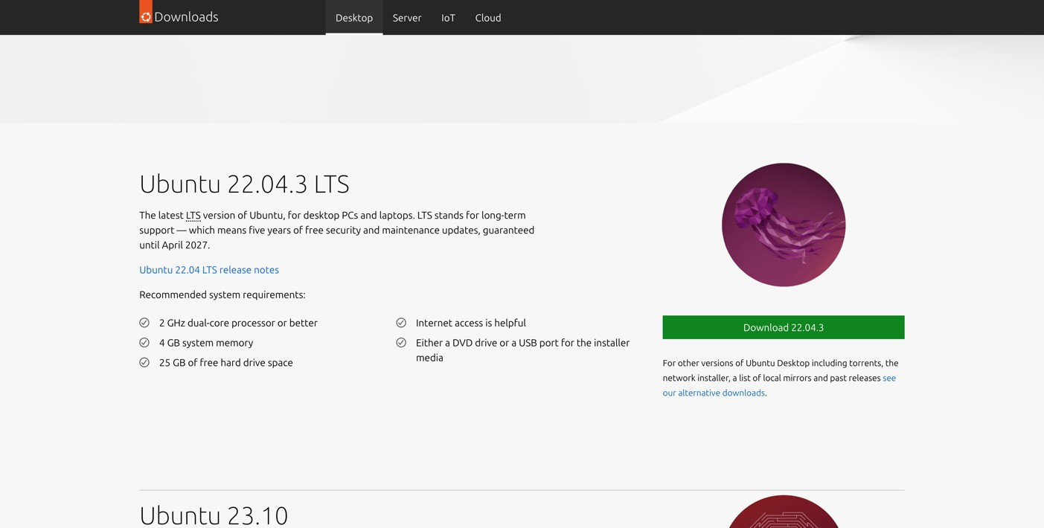

|  |  |  |
| --- | --- | --- |
| - | Create a New Virtual Machine | : |
| * Open VirtualBox and click on the "New" button. * Name your virtual machine (e.g., Ubuntu) and select the type as "Linux" and version as "Ubuntu (64-bit)" (assuming you're installing a 64-bit version). | | |

**STEP 3**

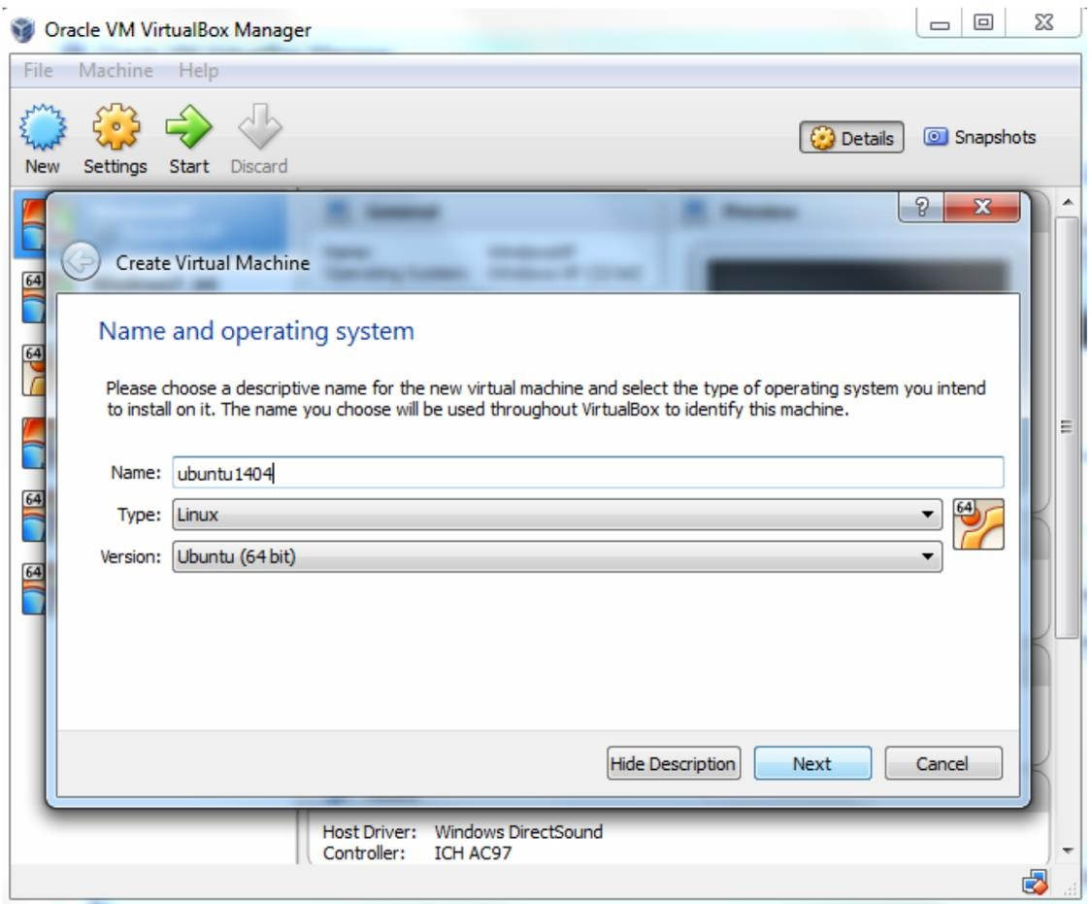

|  |  |
| --- | --- |
| • | Allocate memory (RAM) to the virtual machine. It's recommended to allocate at least 2GB for smooth operation. |

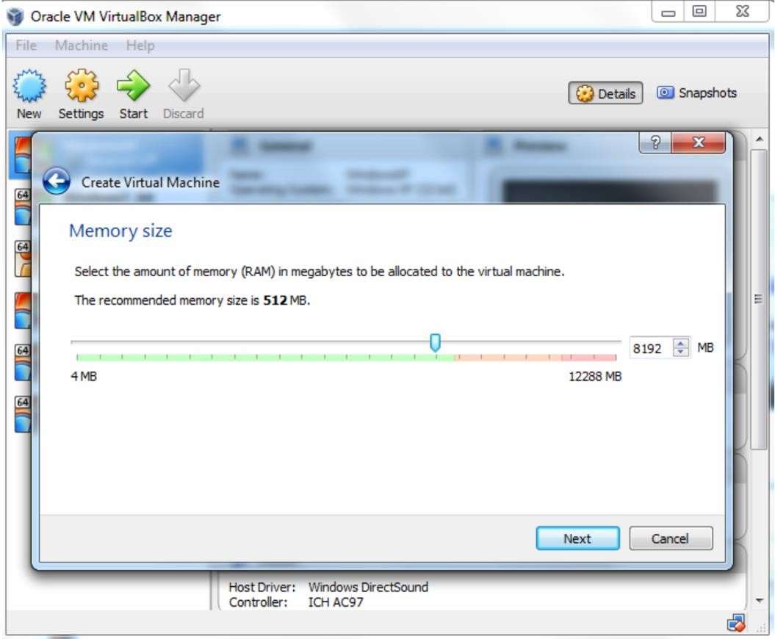

|  |  |
| --- | --- |
| • | Create a virtual hard disk now. Choose the recommended size or adjust as needed. Select "VDI (VirtualBox Disk Image)" as the hard disk file type. |

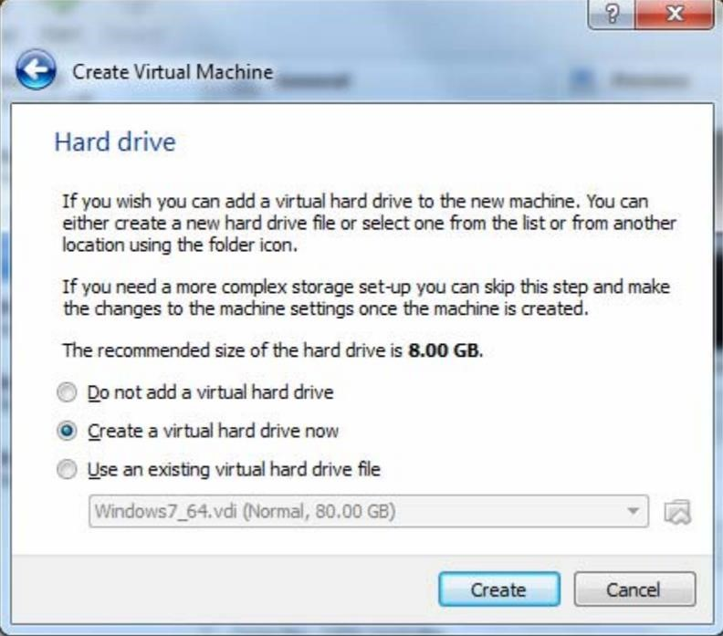

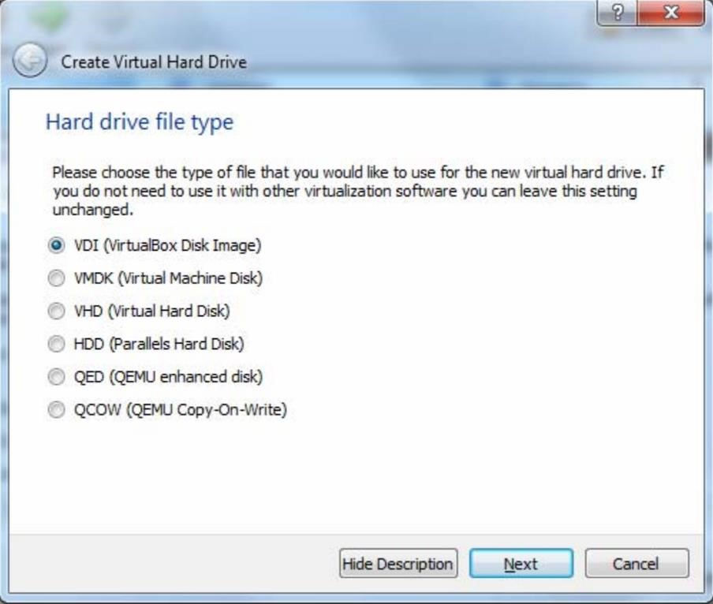

|  |  |
| --- | --- |
| • | Choose "Dynamically allocated" for the storage on physical hard disk, unless you have specific needs for fixed size allocation. |

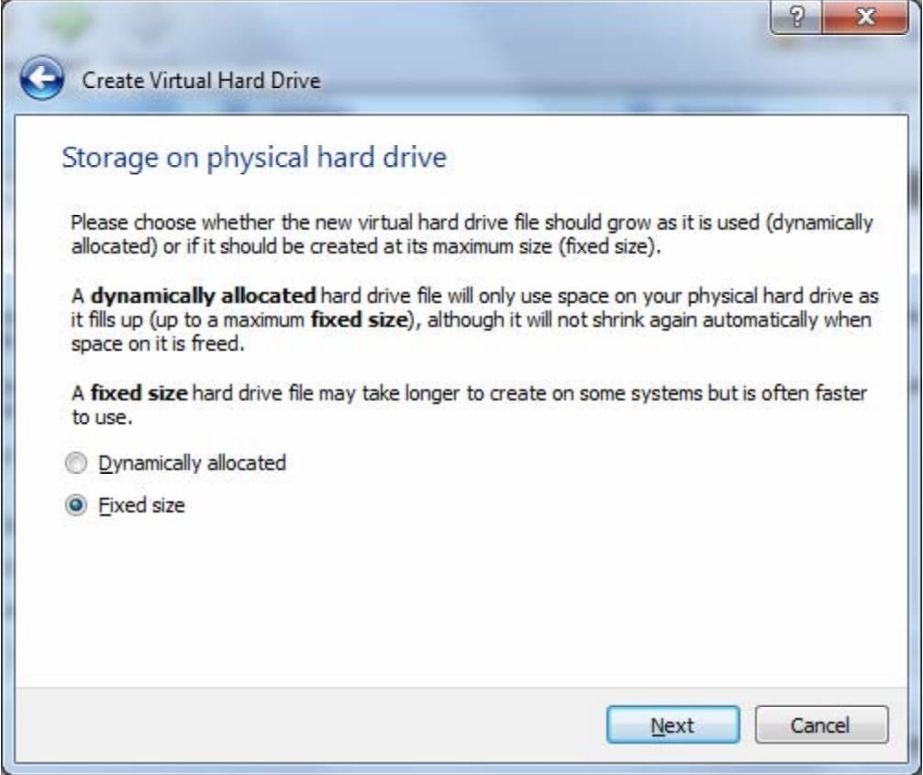

|  |  |
| --- | --- |
| • | Click 'Create' button and VirtualBox will generate Ubuntu virtual machine. |

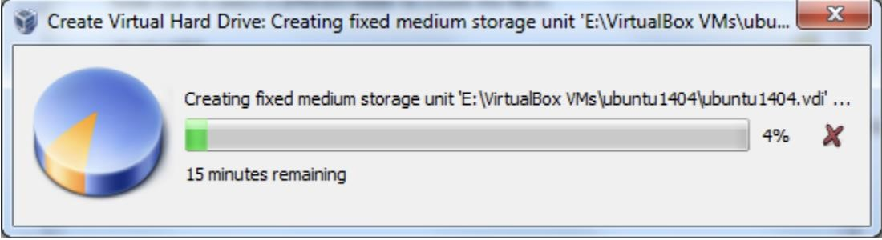

**STEP 4-** Select your new virtual machine and click 'Settings' button. Click on 'Storage' category and then 'Empty' under Controller: IDE. Click "CD/DVD" icon on right hand side and select the ubuntu ISO file to mount.

Note that if you have not downloaded 64-bit Ubuntu ISO file, you can check out this page for more information. When downloading Ubuntu ISO file, make sure to select 64-bit version. Also make sure the VT-x/Virtualization Technology has been enabled in your computer's BIOS/Basic Input Output System.

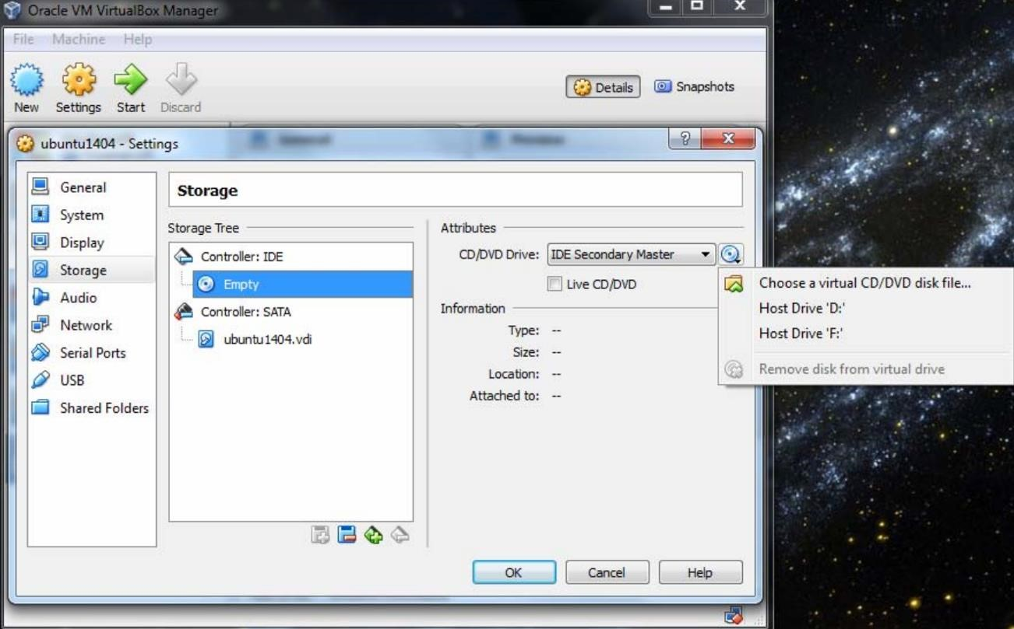

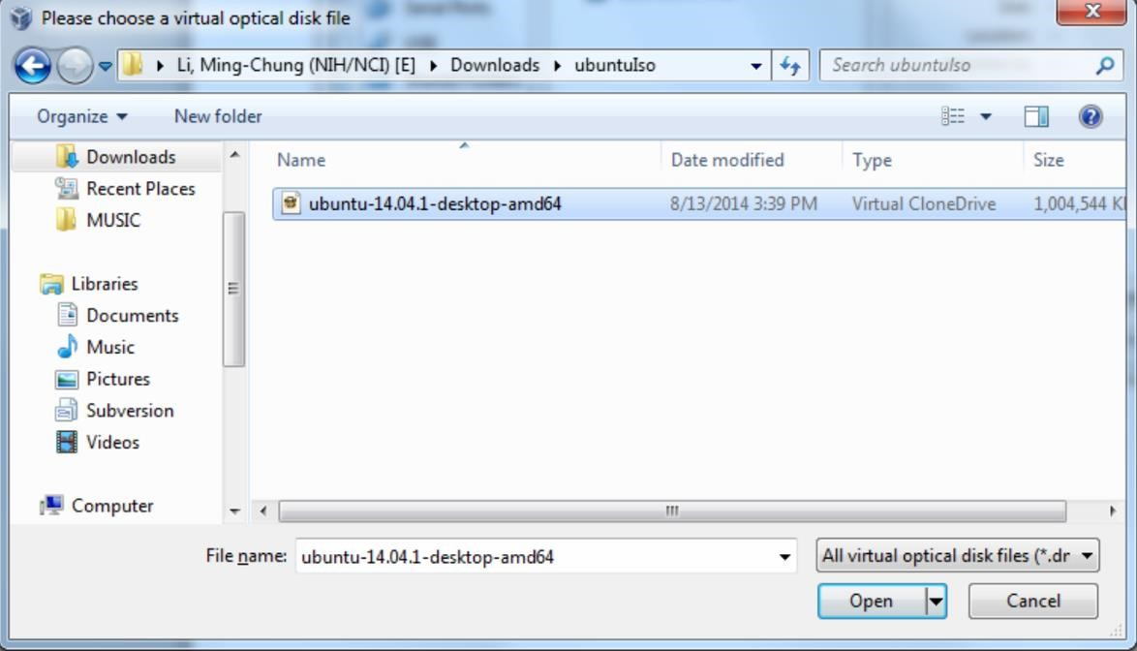

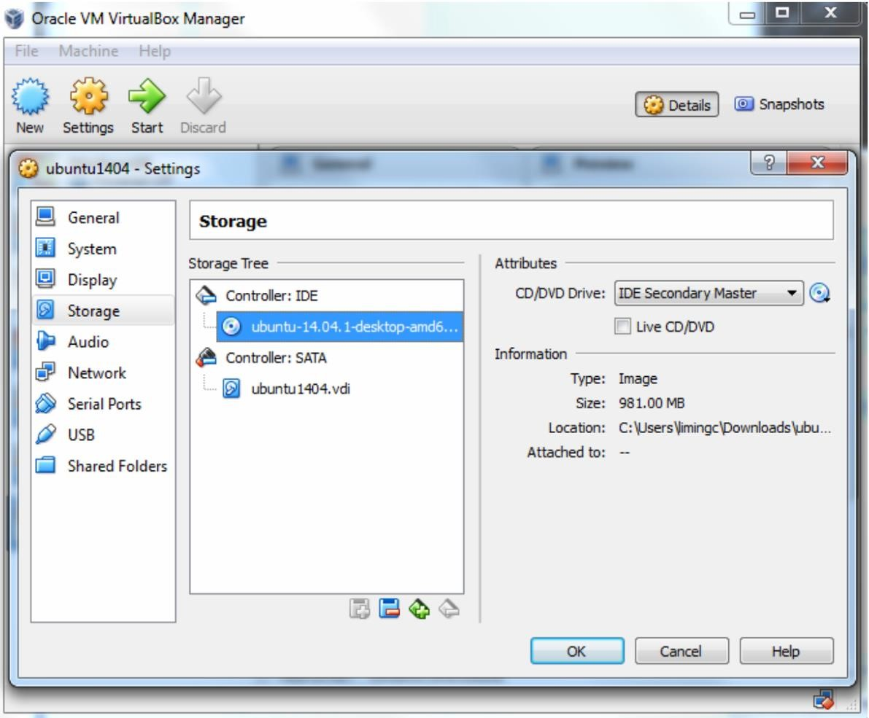

|  |  |  |
| --- | --- | --- |
| **STEP 3-** |  | **Install Ubuntu** |

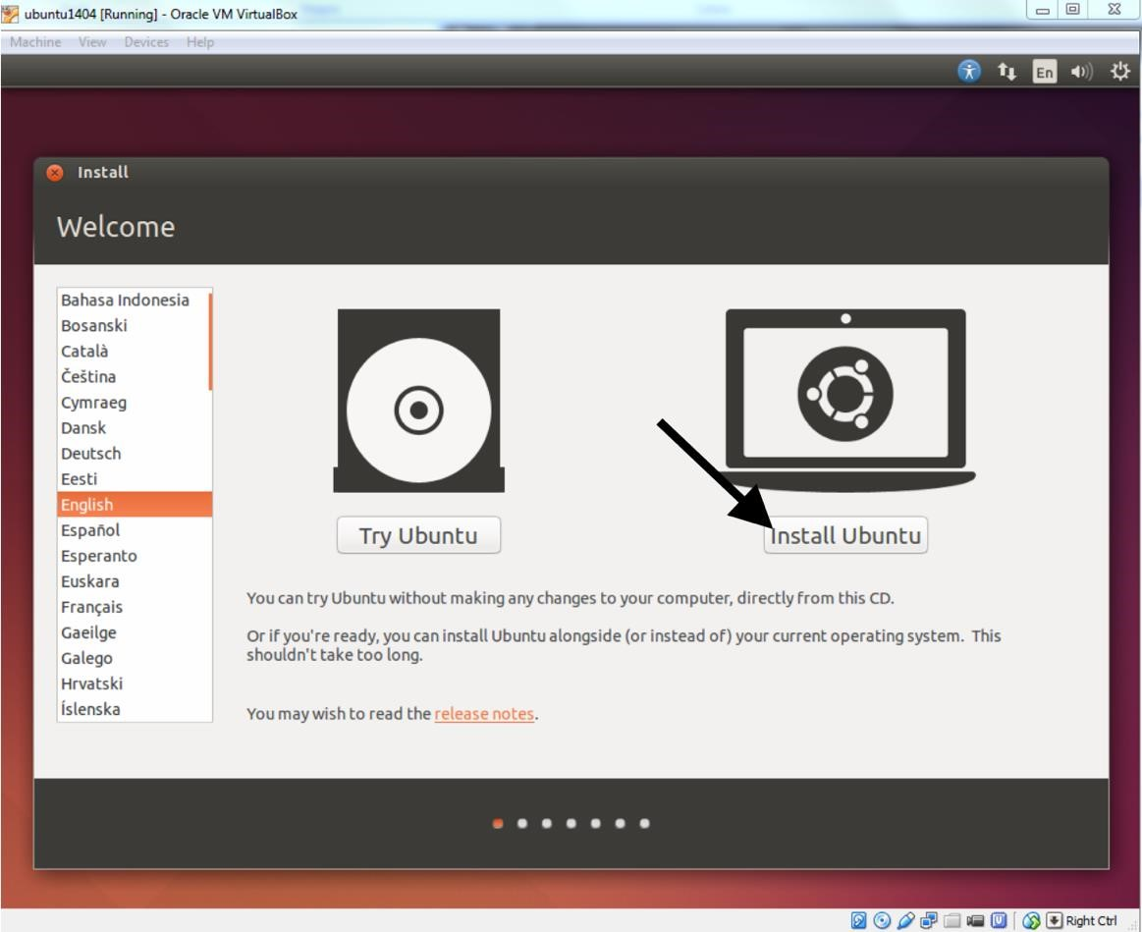

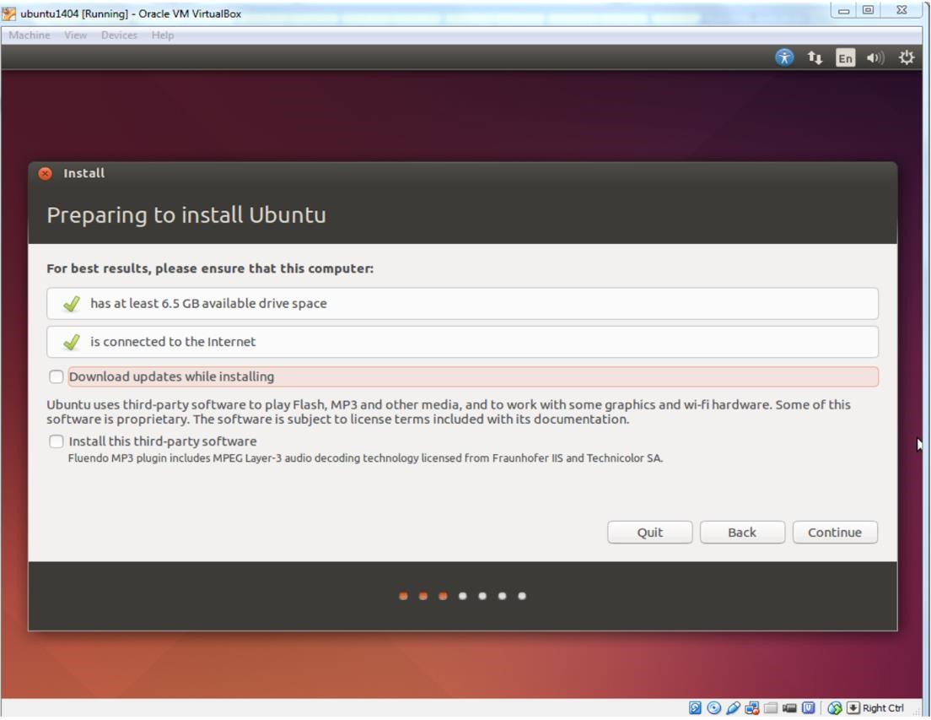

Make sure 'Erase disk and install Ubuntu' option is selected and click 'Install Now' button.

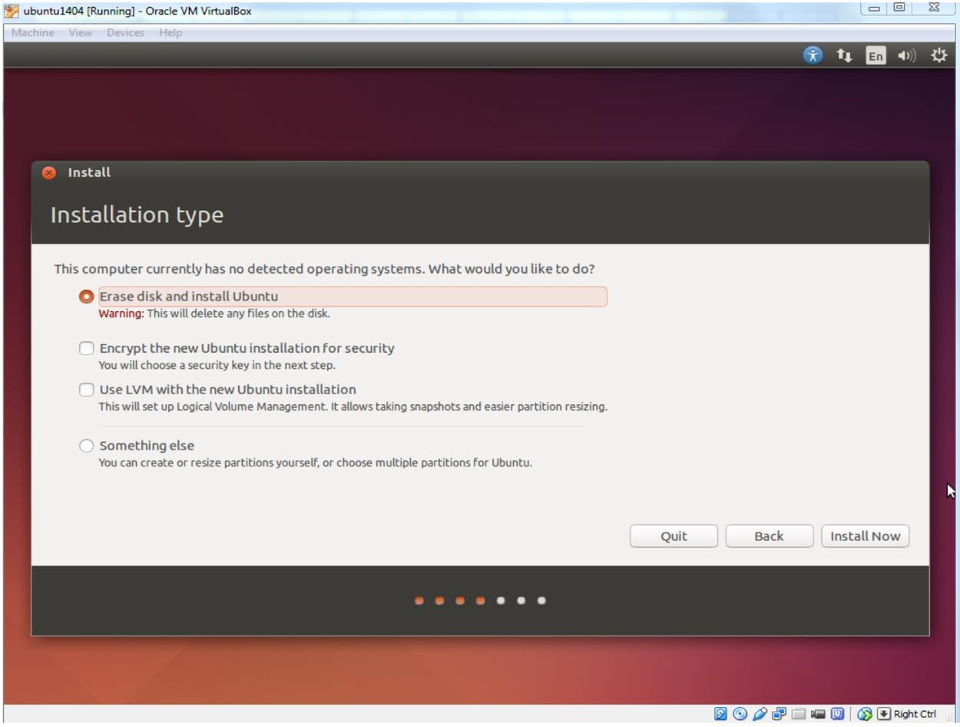

Ubuntu will ask you a few questions. If the default is good, click 'Continue' button.

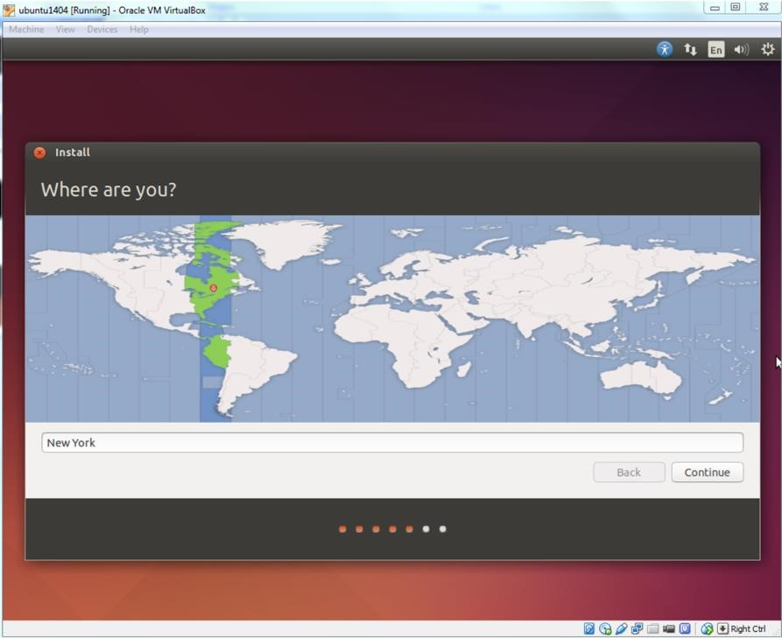

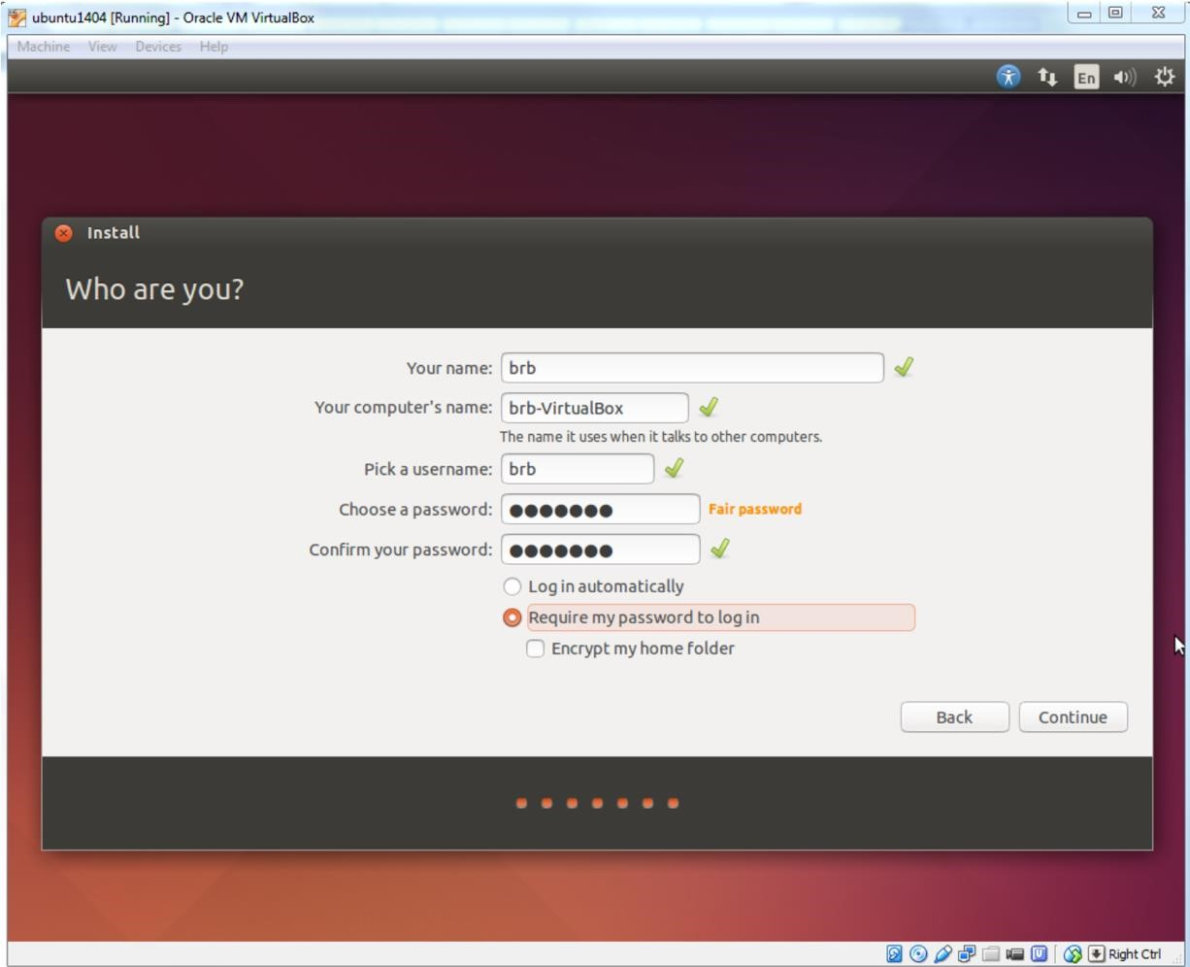

The installation will continue until it is finished.

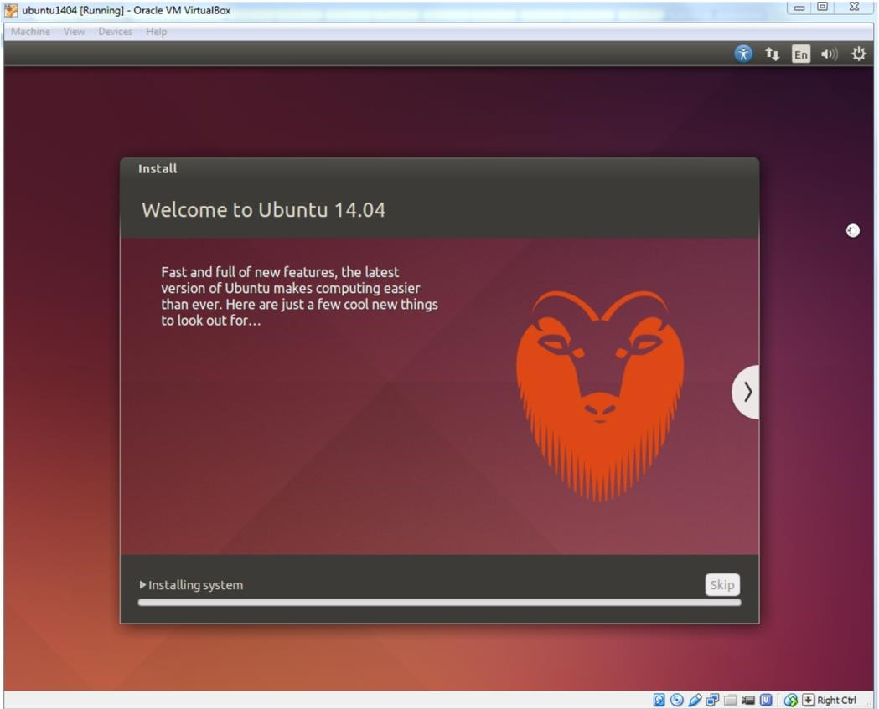

After installation is complete, click 'Restart Now' button. When you see a screen with a black background saying 'Please remove installation media and close the tray (if any) then press ENTER:', just follow it.

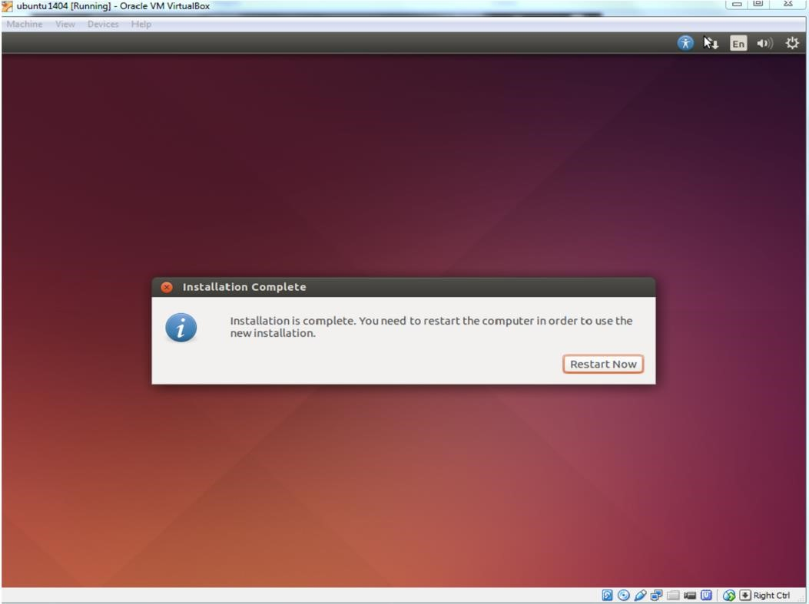

Enter the password you have chosen and press 'Enter'.

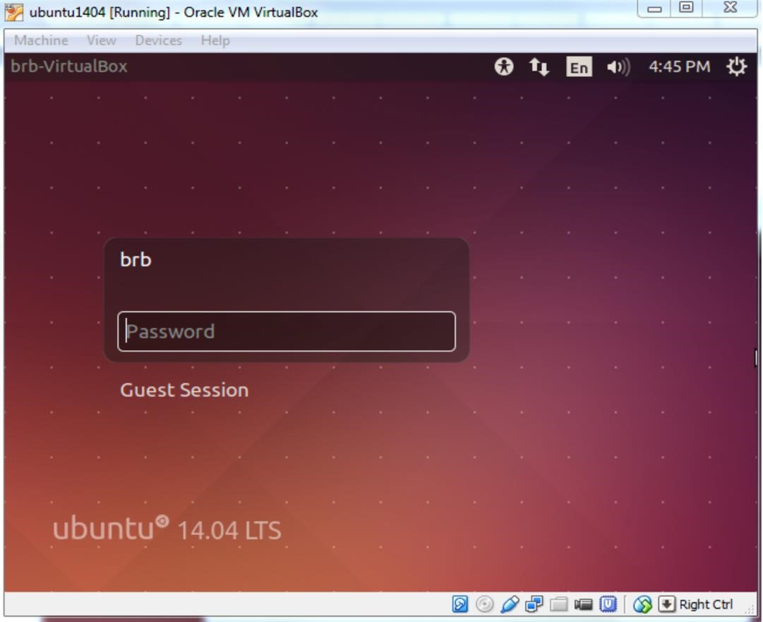

The Ubuntu Desktop OS is ready. You may find the desktop screen is too small. Don't worry. You can solve this easily with "VirtualBox Guest Additions".

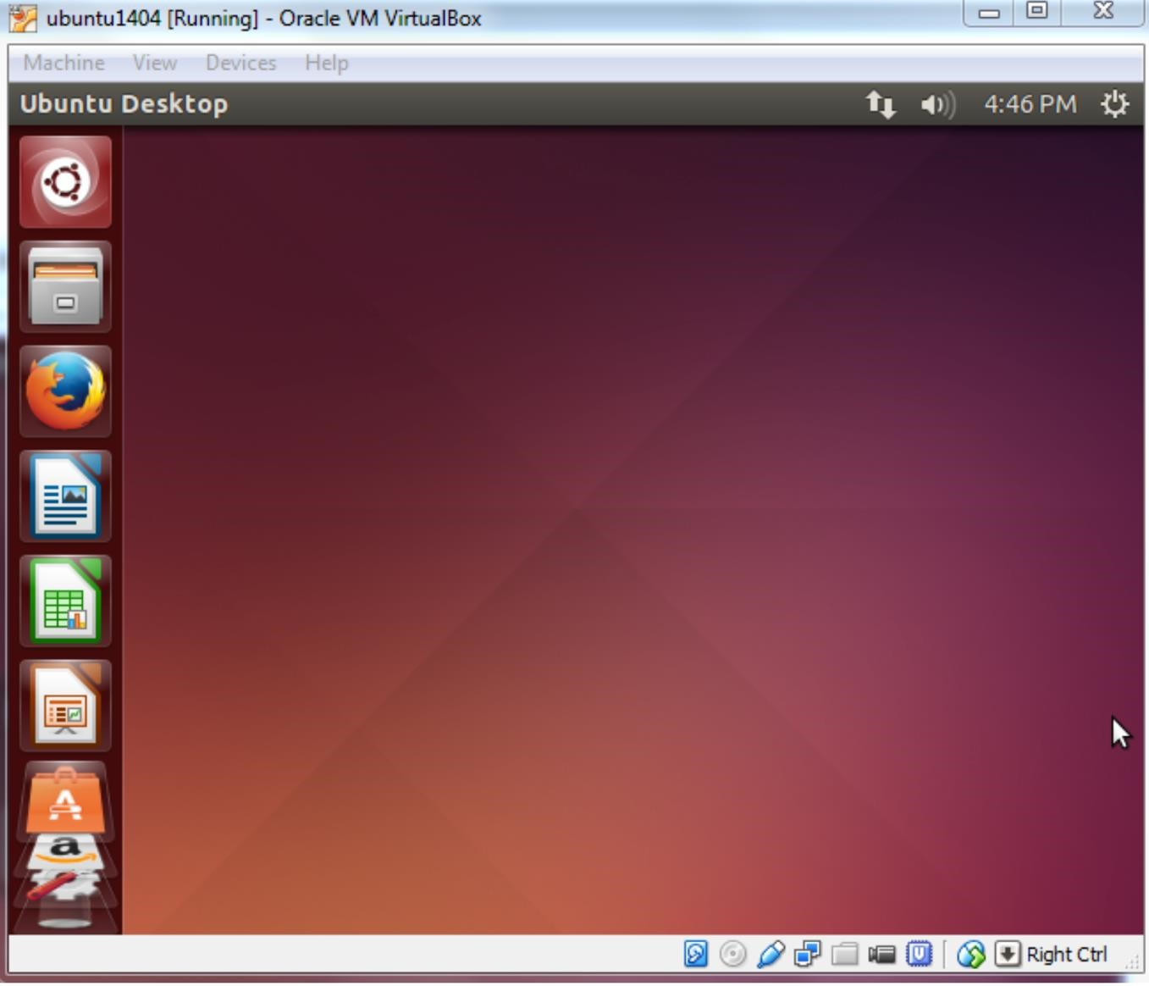

**Program 1:** b) Introduction to GCC compiler: Basics of GCC, Compilation of program, Execution of program

GCC (GNU Compiler Collection) is a widely used open-source compiler system developed by the GNU Project. It supports various programming languages, including C, C++, Objective-C, Fortran, Ada, and Go. GCC is renowned for its robustness, portability, and compliance with various language standards.

* **A brief history of GCC**

The original author of the GNU C Compiler (GCC) is Richard Stallman, the founder of the GNU Project. The GNU project was started in 1984 to create a complete Unix-like operating system as free software, in order to promote freedom and cooperation among computer users and programmers. Every Unix-like operating system needs a C compiler, and as there were no free compilers in existence at that time, the GNU Project had to develop one from scratch. The work was funded by donations from individuals and companies to the Free Software Foundation, a non-profit organization set up to support the work of the GNU Project. The first release of GCC was made in 1987. This was a significant breakthrough, being the first portable ANSI C optimizing compiler released as free software. Since that time, GCC has become one of the most important tools in the development of free software. A major revision of the compiler came with the 2.0 series in 1992, which added the ability to compile C++. In 1997, an experimental branch of the compiler (EGCS) was created to improve optimization and C++ support. Following this work, EGCS was adopted as the new mainline of GCC development, and these features became widely available in the 3.0 release of GCC in 2001. Over time, GCC has been extended to support many additional languages, including Fortran, ADA, Java, and Objective-C. The acronym GCC is now used to refer to the “GNU Compiler Collection”. Its development is guided by the GCC Steering Committee, a group composed of representatives from GCC user communities in industry, research, and academia.

* **Basics of GCC**

**Installation**: GCC is usually pre-installed on Unix-like operating systems such as Linux. However, if it's not installed, you can easily install it using your package manager. For example, on Ubuntu, you can install GCC by running:

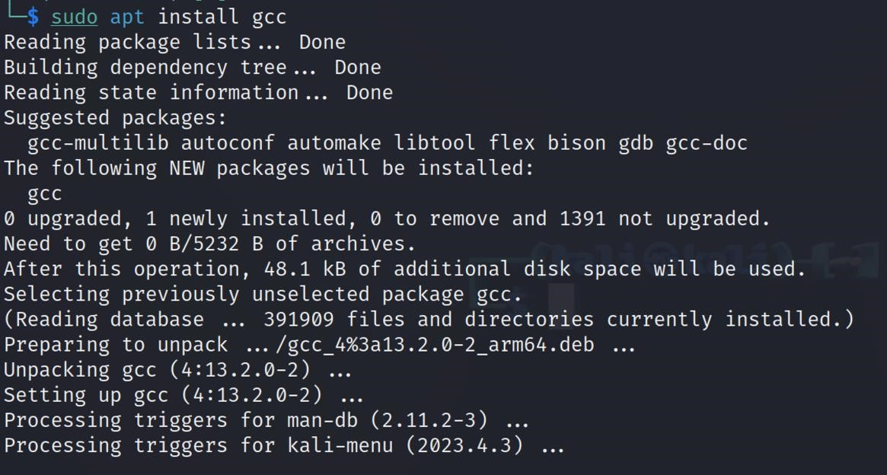

* **Compilation of program**

1. Create a source code file**:**



1. Edit the Source Code file**:**

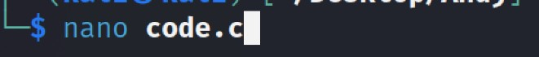

Save

changes

in

Nano

:

•

After writing your C code, press

Ctrl

+

O

to save the changes.

•

Press

Enter

to confirm the filename.

•

Press

Ctrl

+

X

to exit Nano.

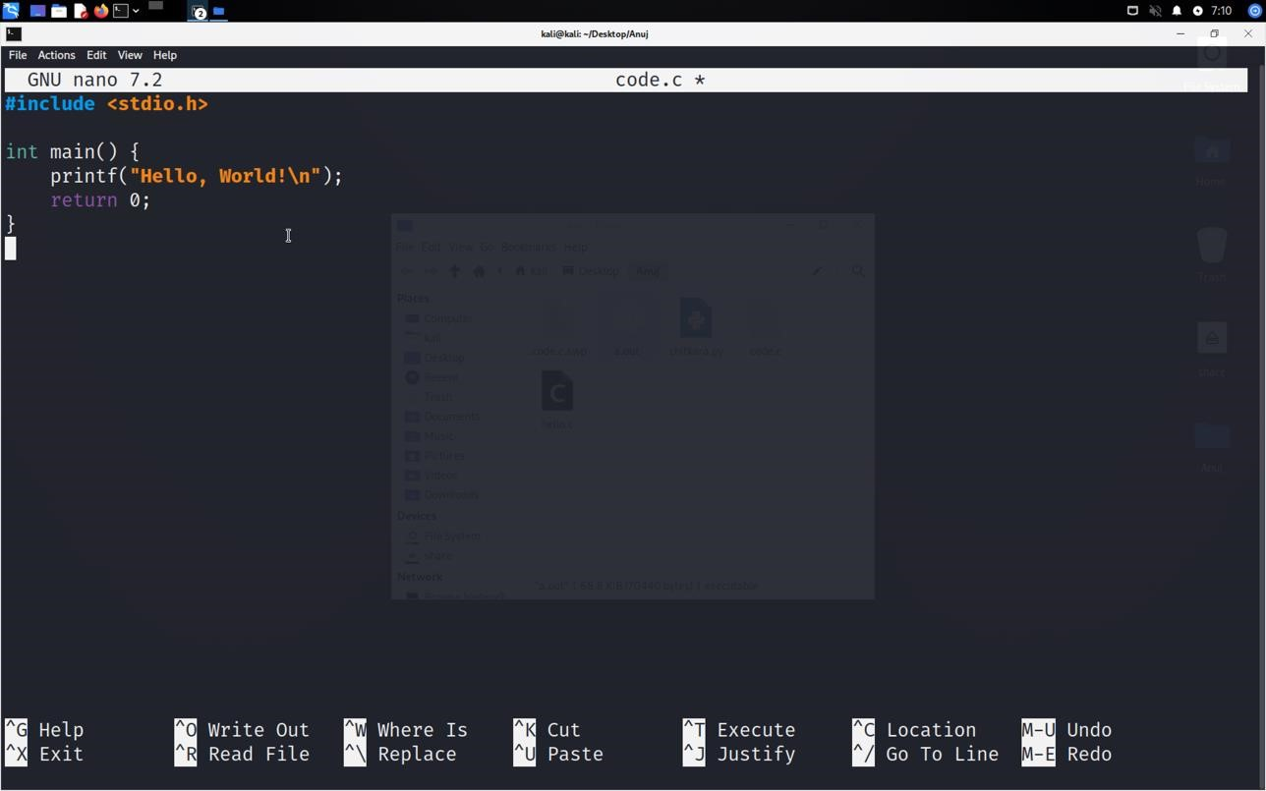

1. Compile the Program using GCC**:**



• **Execute the Compiled Program:**

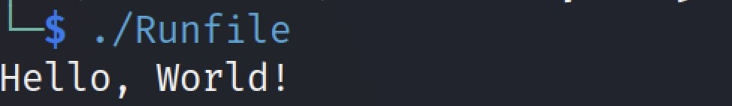

This command executes the compiled program

**Program 1:** c) Time Stamping in Linux

In Linux, you can use the **date** command to display or set the system date and time. To add a timestamp to your C program, you can use the **time()** function from the **time.h** header file.

**Source Code:**

|  |
| --- |
| #include <stdio.h>  #include <time.h>    int main() {  // Get the current time time_t currentTime; struct tm *localTime; time(&currentTime);  localTime = localtime(&currentTime);    // Print the timestamp  printf("Timestamp: %s", asctime(localTime));    return 0;  } |

**Explaination:**

|  |  |  |  |  |  |
| --- | --- | --- | --- | --- | --- |
| • | | **time(&currentTime)**: This function gets the current system time (in seconds since the Epoch) and | | | |
|  |  | stores it in the **currentTime** variable. | | | |
|  | • | **localtime(&currentTime)**: This function converts the time in seconds to a structure representing a local time, and stores it in the **localTime** variable. | | | |
|  | • | **asctime(localTime)**: This function converts the **localTime** structure to a human-readable string repre- | | | |
|  | sentation of the time, and returns a pointer to this string. This string includes the date, time, and timezone information. | | | |
| • | | **printf("Timestamp: %s", ...)** | : This line prints the timestamp obtained from | **asctime()** | to the console. |

**Output:**

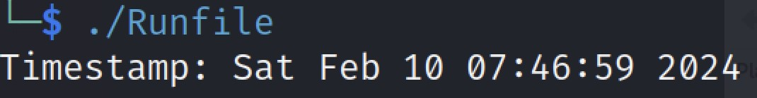

**Program 1:** d) Automating the Execution using Make File

To automate the execution of your C program using a Makefile, you can define rules that specify how to compile and run your program.

**Source Code:**

# Define compiler

CC = gcc

# Define compiler flags

CFLAGS = -Wall -Wextra

# Define target executable

TARGET = Runfile

# Define source files

SRCS = code.c

# Define objects

OBJS = $(SRCS:.c=.o)

# Default rule to build the executable

all: $(TARGET)

# Rule to build the executable

$(TARGET): $(OBJS)

$(CC) $(CFLAGS) -o $@ $^

# Rule to compile source files

%.o: %.c

$(CC) $(CFLAGS) -c $< -o $@

# Rule to clean up generated files clean:

rm -f $(TARGET) $(OBJS)

To use this Makefile:

|  |  |  |  |
| --- | --- | --- | --- |
| 1. Save it as **Makefile** (case-sensitive) in the same directory as your source code (**code.c**). | | | |
|  | 2. Run **make** command in the terminal to build the executable. | | |
| 3. Run | **./Runfile** | to execute the program. |

**Output:**

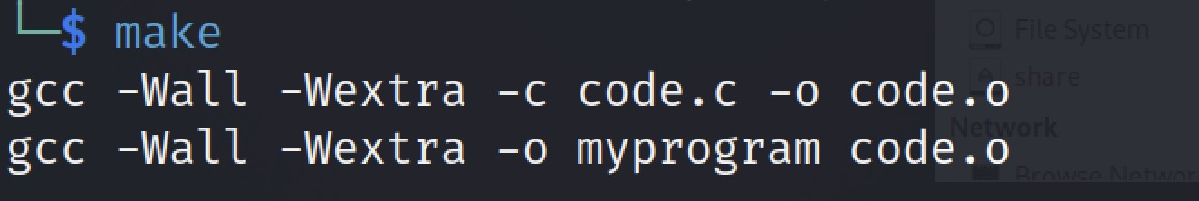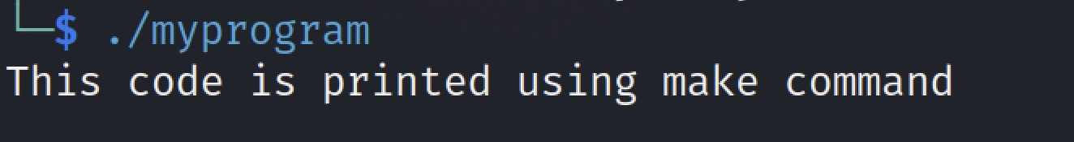

**Program 2:** Implement the basic and user status commands like: su, sudo, man, help, history, who, whoami, id, uname, uptime, free, tty, cal, date, hostname, reboot, clear

**Output:**

1. *su :*

The **su** command stands for "switch user" or "substitute user".

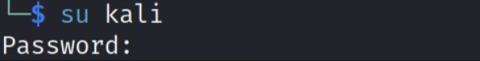

1. ***sudo :***

Execute a single command with elevated privileges**:**

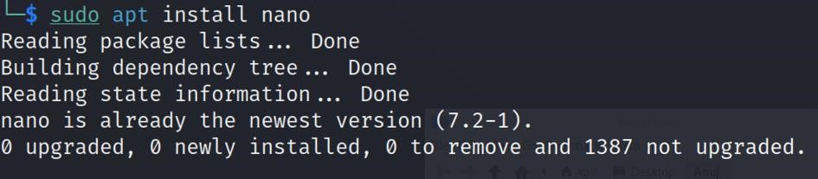

Open a root shell:

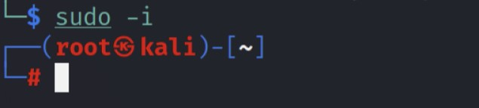

1. ***man :***

The **man** command is used in Unix-like operating systems to display the manual pages for a given command.



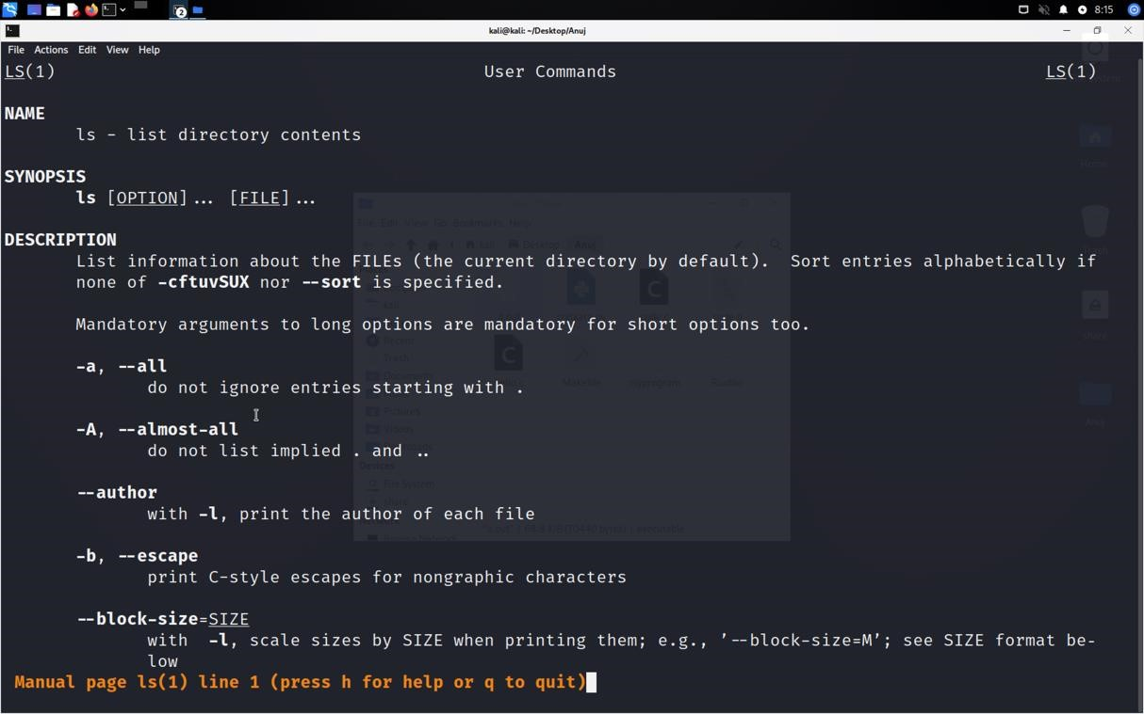

1. ***history :***

The **history** command in Unix-like operating systems, , is used to display a list of previously executed commands in

the current shell session

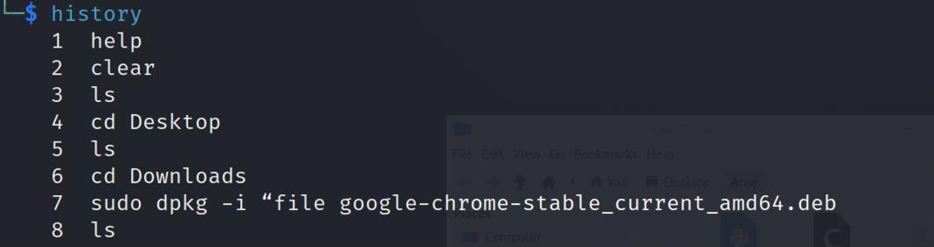

1. ***who :***

used to display information about users who are currently logged in to the system.

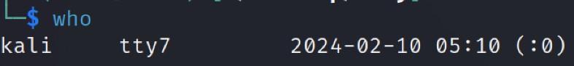

1. ***whoami:***

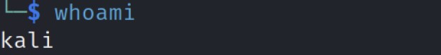

1. ***id :***



1. ***uname :***

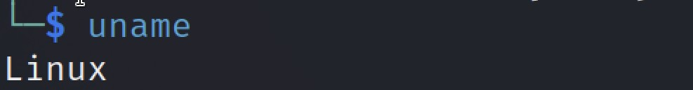

1. ***uptime:***



1. ***free :***

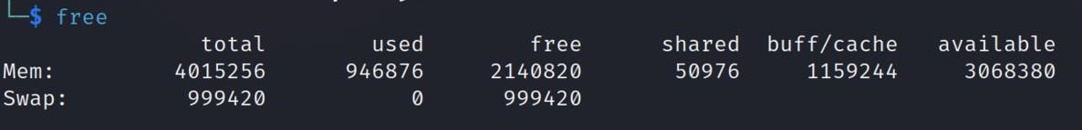

1. ***tty :***

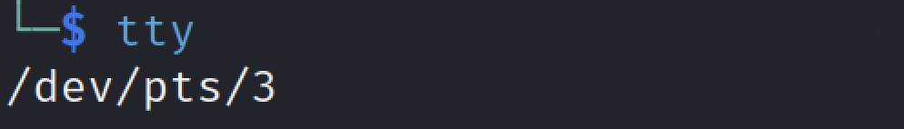

1. ***date :***

|  |
| --- |
| The **date** command is useful for various tasks, including displaying timestamps in scripts, setting system clocks, and |
| troubleshooting time-related issues. |

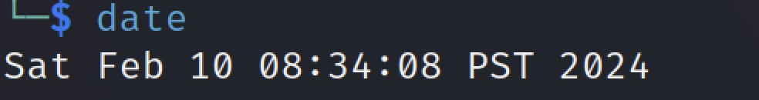

|  |  |  |  |  |  |  |  |  |
| --- | --- | --- | --- | --- | --- | --- | --- | --- |
| 1. |  | Display the date and time in a specific format | | | | : | | |
|  |  | date +"format_string" |  | | | | | |
| Replace format_string with the desired format for displaying the date and time. You can use special | | | | | | | |
|  | format specifiers to customize the output. For example: | | | | | | |
|  | date +"%Y-%m-%d %H:%M:%S" | | |  | | | |
| This will display the date and time in the format | | | | | | YYYY-MM-DD HH:MM:SS | . |
| 2. |  | Set the system date and time | | : | | | | |

sudo date "MMDDhhmm[[CC]YY][.ss]"

Replace "MMDDhhmm[[CC]YY][.ss]" with the desired date and time. The format is MM for month, DD for day, hh for hour (24-hour format), mm for minute, [[CC]YY] for year (optional), and [.ss] for second (optional). You need to have root privileges (using sudo) to set the system date and time.

1. ***hostname :***

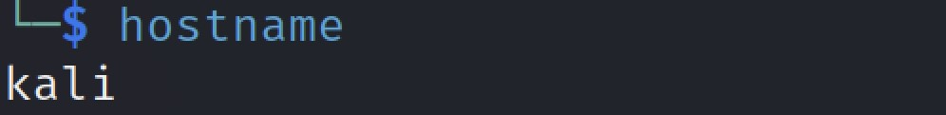

1. ***reboot :***

It initiates a system reboot, causing the operating system to shut down all processes, stop the kernel, and then restart the system

|  |
| --- |
| It's a simple command that helps improve readability by removing |
| previous output from the terminal, making it easier to focus on new commands and output. |

1. ***clear :*** 

**Program 3:** a) Implement the commands that is used for Creating and Manipulating files: cat, cp, mv, rm, ls and its options, touch and their options, which is, where is, what is

**Output:**

1. *cat :*

The **cat** command in Linux is a utility used for concatenating files and printing the contents of files to the standard output (usually the terminal). Its name is derived from "concatenate".

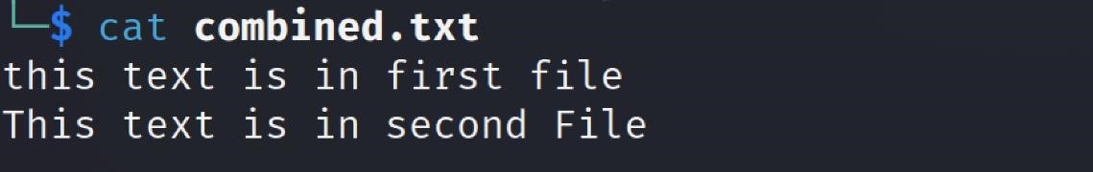

1. *mv :*

The **cp** command in Linux is used to copy files and directories from one location to an-

other. Here's how it's commonly used:

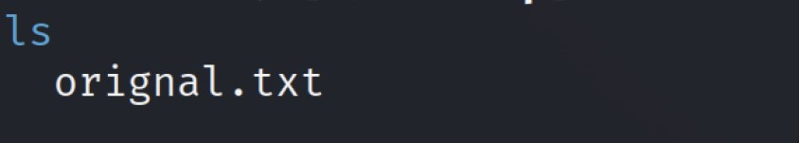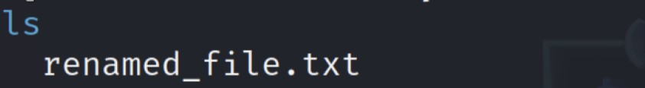

1. *rm :*

The **rm** command is used to remove files or directories in Unix-like operating systems, including Linux and macOS. It stands for "remove".

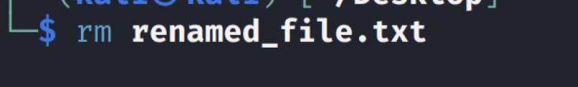

1. *ls :*

The **ls** command in Unix-like operating systems (such as Linux and macOS) is used to list the files and directories in the current directory.

*5.*

*t*

*ouch*

*:*

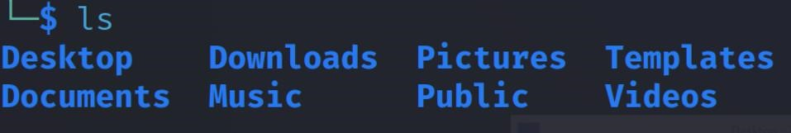

The **touch** command in Unix-like operating systems (such as Linux and macOS) is used to create a new empty file or update the timestamp of an existing file.

To create a new empty file using **touch**, simply open your terminal or command prompt and type:



1. *whereis :*

The **whereis** command in Unix-like operating systems is used to locate the binary, source, and manual page files for a command. It helps to find out the location of executable files, source code, and manual pages associated with a given command.

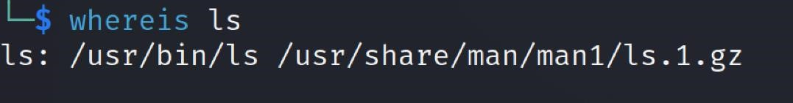

1. *which :*

The **which** command is used in Unix-like operating systems (such as Linux and macOS) to locate the executable file associated with a given command.

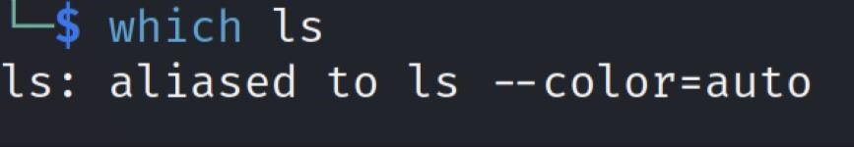

1. *whatis :*

The **whatis** command in Unix-like operating systems is used to display a brief description of a command, function, or system call. It provides a concise summary of what the specified item does without displaying its entire manual page.

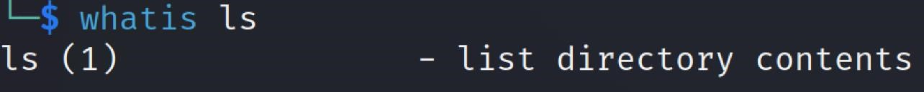

**Program 4:** Implement Directory oriented commands: cd, pwd, mkdir, rmdir, Comparing Files using diff, cmp, comm.

**Output:**

* 1. *cd :*

To use the **cd** command, you simply type **cd** followed by the path of the directory you want to change to. Here are a few examples:



* 1. *pwd :*

The **pwd** command stands for "print working directory." It is used in Unix-like operating systems (such as Linux, macOS, and Unix) to display the current directory path or present working directory.

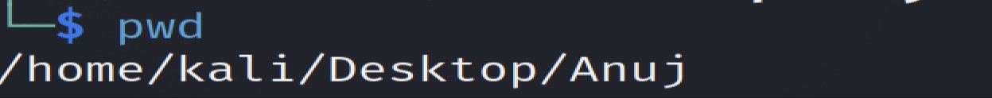

* 1. *mkdir :*

The **mkdir** command is used to create a new directory (folder) in Unix-like operating systems, including Linux, macOS, and Unix. It stands for "make directory."

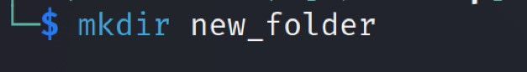

* 1. *rmdir :*

The **rmdir** command is used to remove directories (folders) in Unix-like operating systems, including Linux, macOS, and Unix. However, it can only remove directories that are empty. If a directory contains files or subdirectories, you'll need to use the **rm** command with the **-r** option to recursively remove its contents before using **rmdir**.

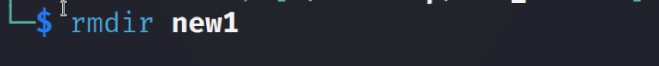

* 1. *Comparing Files using diff :*

|  |
| --- |
| The **diff** command is used in Unix-like operating systems to compare the contents of |
| two files line by line. It displays the differences between the files in a human-readable format. |

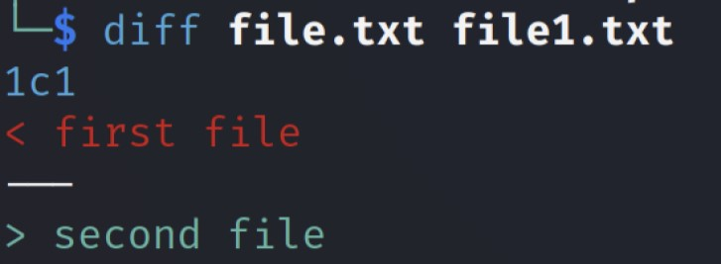

* 1. *Cmp :*

The **cmp** command is used to compare two files byte by byte and report the first differing byte and its offset (position) in each file. It is commonly used to check whether two files are identical or to find the differences between them.

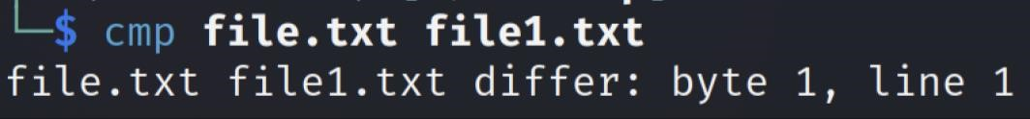

* 1. *comm :*

The **comm** command is used to compare two sorted files line by line. It can be particularly useful when you want to find lines that are unique to one file or lines that are common to both files.

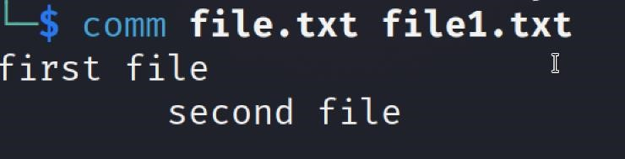

## **Program 5:** Write a program and execute the same to demonstrate how to use terminal commands in C program (using system() function)

**STEP 1**- let's create a C program file named **terminal_commands.c**. You can do this using a by using the **touch** command in the terminal:



**STEP 2**- Now, open **terminal_commands.c** in nano text Editor using this command **nano terminal_commands.c** and add the following code to it:



Press ctrl + X to save the file

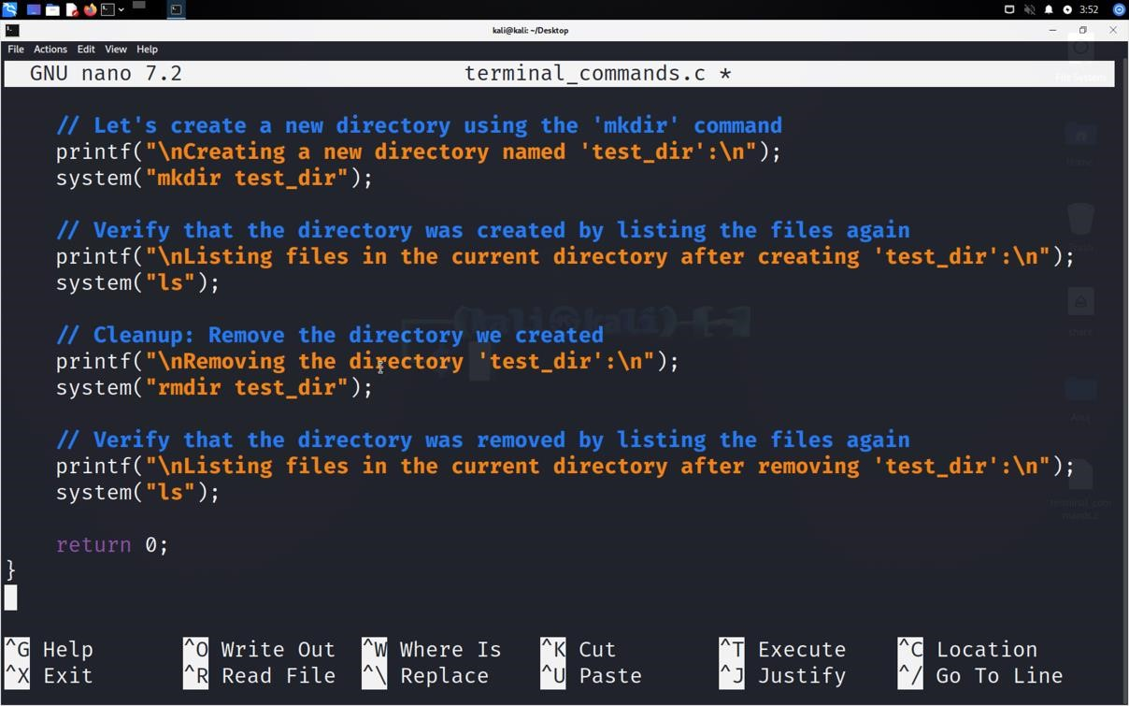

**SOURCE CODE:**

|  |
| --- |
| #include <stdio.h>  #include <stdlib.h>    int main() {  // Use the system() function to execute terminal commands  // For example, let's list the files in the current directory using the 'ls' command printf("Listing files in the current directory:\n"); system("ls");    // Let's create a new directory using the 'mkdir' command printf("\nCreating a new directory named 'test_dir':\n"); system("mkdir test_dir");    // Verify that the directory was created by listing the files again printf("\nListing files in the current directory after creating 'test_dir':\n"); system("ls");    // Cleanup: Remove the directory we created printf("\nRemoving the directory 'test_dir':\n"); system("rmdir test_dir");    // Verify that the directory was removed by listing the files again printf("\nListing files in the current directory after removing 'test_dir':\n"); system("ls");    return 0;  } |

**OUTPUT:**

**Compile the C Program**: Now, let's compile the C program using a C compiler. We'll use **gcc**

for this:



**Execute the Program**: Finally, let's run the compiled executable:

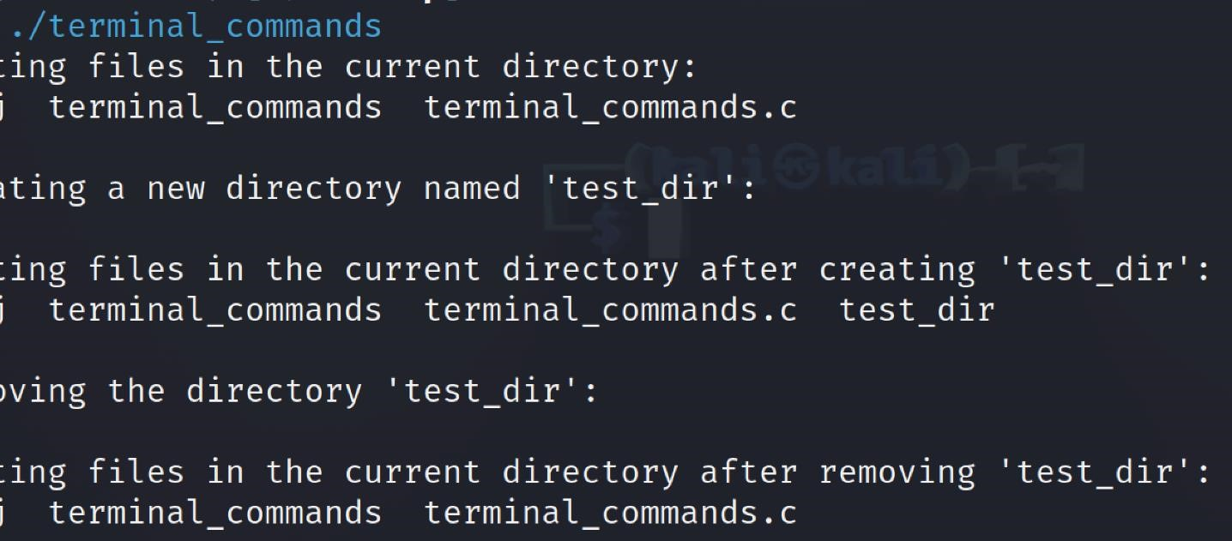

**6:** Write a program to implement process concepts using C language by printing process Id.

**ALGORITHM:**

1. The header files stdio.h and unistd.h are included to use the printf() function and getpid() function, respectively.
2. The main() function is declared.
3. The getpid() function is called to get the process ID, and the result is stored in the variable pid.
4. The process ID is printed using the printf() function.
5. The main function is ended with the return 0 statement.
6. It will print the process ID.

**SOURCE CODE:**

#include <stdio.h>

#include <sys/types.h>

#include <unistd.h>

int main() {

pid_t p;

p = fork();

if (p < 0) {

printf("Error in forking\n");

} else if (p == 0) {

printf("Child process. PID=%d\n", getpid());

} else {

printf("Parent process. Child PID=%d\n", p);

}

return 0;

}

**OUTPUT:**

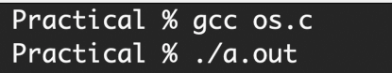

**7:** Write a program to create and execute process using fork() and exec() system calls.

**ALGORITHM:**

1. We will create two files with the extension of “.c.” After their creation, we will write respective codes in them and execute them to see the result.
2. We have used the “unistd.h” header as it contains all information of families of exec function.
3. We have printed the current process’s id.
4. We have created a character array having NULL in the end for the termination.
5. We have called the execfile function.
6. The output of the respective codes can be obtained by using the following commands.
   * gcc -o execFileDemo.c execFileDemo
   * gcc execfile.c -o execfile
   * ./execFileDemo
   * ./execfile

**SOURCE CODE:**

1. **execfile.c**

|  |
| --- |
| 1. #include <stdio.h> 2. #include <unistd.h>  3.   1. int main(int argc, char *argv[]) { 2. printf("We are in execfile.c\n"); 3. printf("PID of execfile.c = %ld\n", (long)getpid()); 4. printf("---------------------------\n"); 5. printf("---------------------------\n");   9.   1. return 0; 2. } |

1. **execFileDemo.c**

|  |
| --- |
| #include <stdio.h>  #include <unistd.h>    int main(int argc, char *argv[]) {  printf("PID of execFileDemo.c = %d\n", getpid());  char *args[] = {"h", "c", "hello", NULL}; execv("./execfile", args); printf("Back to execFileDemo.c\n"); printf("---------------------------\n"); printf("---------------------------\n"); return 0;  } |

**OUTPUT:**

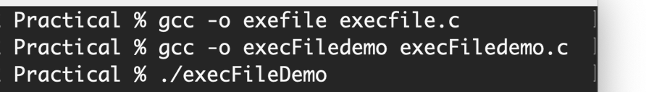

**8:** Write a C program to implement FCFS (First Come First Serve) and SJF (Shortest Job First) scheduling algorithms.

**FCFS**: First-Come, First-Served Scheduling Algorithm

First Come, First Served (FCFS) is the CPU scheduling algorithm in which the CPU is allocated to the processes in the order they are queued in the ready queue. FCFS follows non-pre emptive scheduling which mean once the CPU is allocated to a process it does not leave the CPU until the process will not get terminated or may get halted due to some I/O interrupt.

***Example***

Let’s say, there are four processes arriving in the sequence as P2, P3, P1 with their corresponding execution time as shown in the table below. Also, taking their arrival time to be 0.

|  |  |  |
| --- | --- | --- |
| **Process** | **Order of arrival** | **Execution time in msec** |
| P1 | 3 | 15 |
| P2 | 1 | 3 |
| P3 | 2 | 3 |

Gantt chart showing the waiting time of processes P1, P2 and P3 in the system

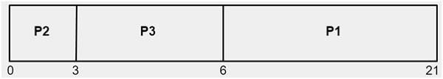

As shown above,

The waiting time of process P2 is 0

The waiting time of process P3 is 3 The waiting time of process P1 is 6

Average AWT time = (0 + 3 + 6) / 3 = 3 msec.

As we have taken arrival time to be 0 therefore turnaround time and completion time will be same.

**SOURCE CODE:**

|  |
| --- |
| #include <stdio.h>    int waitingtime(int proc[], int n, int burst_time[], int wait_time[]) { wait_time[0] = 0; for (int i = 1; i < n; i++)  wait_time[i] = burst_time[i - 1] + wait_time[i - 1]; return 0;  }    int turnaroundtime(int proc[], int n, int burst_time[], int wait_time[], int tat[]) { for (int i = 0; i < n; i++)  tat[i] = burst_time[i] + wait_time[i]; return 0;  }    int avgtime(int proc[], int n, int burst_time[]) { int wait_time[n], tat[n], total_wt = 0, total_tat = 0;    waitingtime(proc, n, burst_time, wait_time);  turnaroundtime(proc, n, burst_time, wait_time, tat);    printf("Processes Burst Waiting Turn around \n"); for (int i = 0; i < n; i++) {  total_wt = total_wt + wait_time[i]; total_tat = total_tat + tat[i];  printf(" %d\t %d\t\t %d \t%d\n", i + 1, burst_time[i], wait_time[i], tat[i]);  }  printf("Average waiting time = %f\n", (float)total_wt / (float)n); printf("Average turn around time = %f\n", (float)total_tat / (float)n);    return 0;  }  int main() {  int proc[] = {1, 2, 3};  int n = sizeof proc / sizeof proc[0]; int burst_time[] = {5, 8, 12}; avgtime(proc, n, burst_time); return 0;  } |

**OUTPUT:**

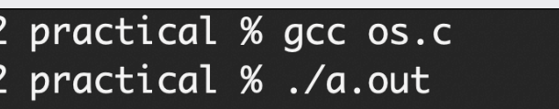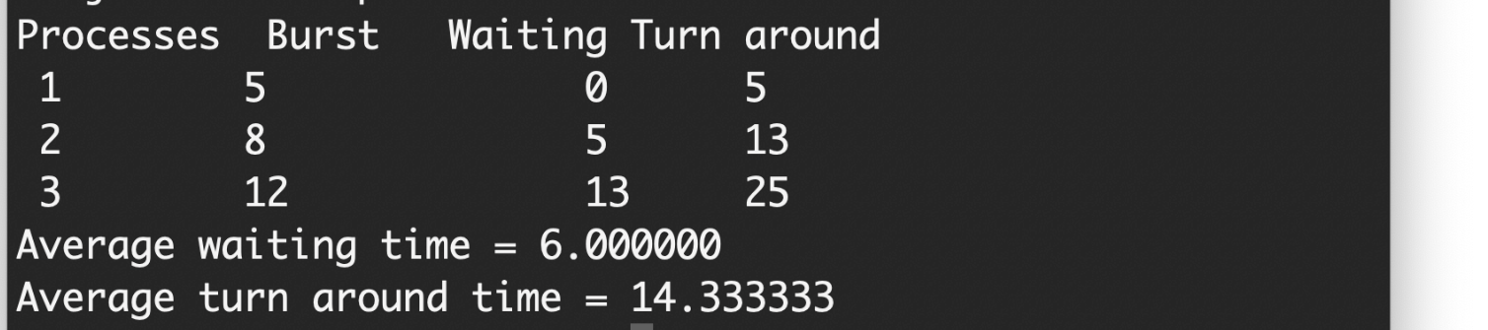

**SJF**: Shortest Job First Scheduling Algorithm

The Shortest Job First (SJF) algorithm is a non-**pre-emptive** CPU scheduling algorithm designed to minimize the average waiting time of processes. It operates by sorting all processes based on their arrival times. From this sorted list, the algorithm selects the process with the shortest burst time, signifying the time it requires to complete its task. The CPU is then allocated to this selected process, allowing it to execute for its designated burst time. Upon completion of its execution, the process is removed from the list, and the algorithm iterates, selecting the next shortest job until all processes are completed. This method ensures that shorter processes are prioritized, potentially reducing overall waiting times and improving system efficiency.

**SOURCE CODE:**

|  |
| --- |
| #include<stdio.h>    int main() {  int bt[20], p[20], wt[20], tat[20], i, j, n, total = 0, pos, temp; float avg_wt, avg_tat;  printf("Enter number of processes:"); scanf("%d", &n);  printf("\nEnter Burst Time:\n");  for(i = 0; i < n; i++) { printf("P%d:", i + 1); scanf("%d", &bt[i]);  p[i] = i + 1;  } |
| for(i = 0; i < n; i++) { pos = i;  for(j = i + 1; j < n; j++) { if(bt[j] < bt[pos]) pos = j;  }  temp = bt[i]; bt[i] = bt[pos];  bt[pos] = temp;    temp = p[i]; p[i] = p[pos];  p[pos] = temp;  }  wt[0] = 0;  for(i = 1; i < n; i++) { wt[i] = 0; for(j = 0; j < i; j++) wt[i] += bt[j]; total += wt[i];  }  avg_wt = (float)total / n; total = 0;  printf("\nProcess\tBurst Time\tWaiting Time\tTurnaround Time\n"); for(i = 0; i < n; i++) { tat[i] = bt[i] + wt[i]; total += tat[i];  printf("\nP%d\t%d\t\t%d\t\t%d", p[i], bt[i], wt[i], tat[i]);  }  avg_tat = (float)total / n;  printf("\n\nAverage Waiting Time = %f", avg_wt); printf("\nAverage Turnaround Time = %f\n", avg_tat); return 0;  } |

**OUTPUT:**

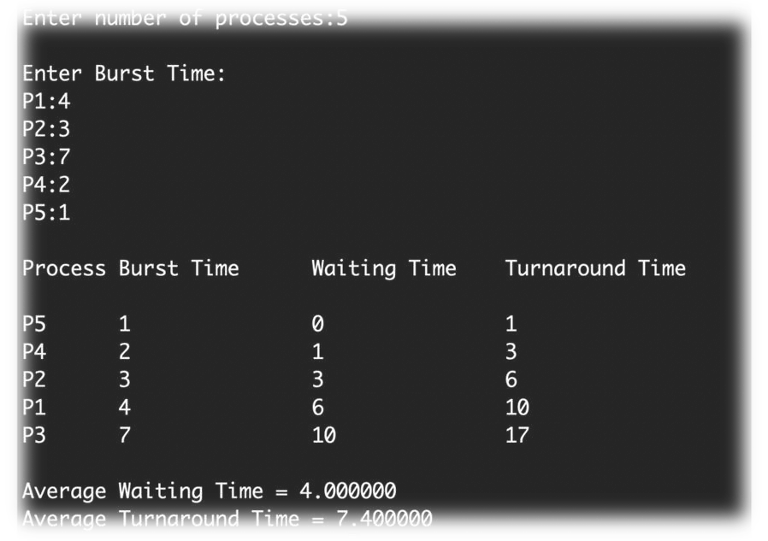

**Program 9:** Write a C program to implement Priority Scheduling and RR (Round-

Robin) scheduling algorithms.

**ROUND ROBIN** : Round Robin Scheduling Algorithm

The Round Robin (RR) scheduling algorithm is a preemptive CPU scheduling technique commonly used in operating systems. In RR, each process is allocated a fixed time slice, known as a time quantum, during which it can execute on the CPU. Processes are placed in a ready queue, and the scheduler selects the process at the front of the queue to run on the CPU. If a process completes within its time quantum, it is removed from the system. Otherwise, it is preempted and placed at the end of the ready queue to await its next turn. RR ensures fairness by providing each process with an equal share of CPU time, making it suitable for time-sharing systems where multiple users need concurrent access to system resources. However, the choice of time quantum affects the trade-off between fairness and responsiveness, as shorter time slices lead to more frequent context switches.

**SOURCE CODE:**

|  |
| --- |
| #include<stdio.h>  int main() {  int i,limit,total=0,x,counter=0,time_quantum;  int wait_time=0,turnaround_time=0,arrival_time[10],burst_time[10],temp[10]; float average_wait_time,average_turnaround_time; printf("\nEnter Total Number of Processes:"); scanf("%d",&limit); x=limit;  for(i=0;i<limit;i++) {  printf("\nEnter Details of Process[%d]\n",i+1); printf("Arrival Time:"); scanf("%d",&arrival_time[i]); printf("Burst Time:"); scanf("%d",&burst_time[i]);  temp[i]=burst_time[i];  }  printf("\nEnter Time Quantum:"); scanf("%d",&time_quantum);  printf("\nProcess ID\tBurst Time\tTurnaround Time\tWaiting Time\n"); for(total=0,i=0;x!=0;) {  if(temp[i]<=time_quantum&&temp[i]>0) { total=total+temp[i]; |
| temp[i]=0;  counter=1;  }  else if(temp[i]>0) {  temp[i]=temp[i]-time_quantum;  total=total+time_quantum;  }  if(temp[i]==0&&counter==1) { x--;  printf("\nProcess[%d]\t%d\t\t%d\t\t%d",i+1,burst_time[i],total-arrival_time[i],total-arrival_time[i]-burst_time[i]); wait_time=wait_time+total-arrival_time[i]-burst_time[i]; turnaround_time=turnaround_time+total-arrival_time[i]; counter=0;  }  if(i==limit-1) {  i=0;  }  else if(arrival_time[i+1]<=total) { i++;  }  else {  i=0;  }  }  average_wait_time=wait_time*1.0/limit; average_turnaround_time=turnaround_time*1.0/limit; printf("\n\nAverage Waiting Time:%f",average_wait_time); printf("\nAverage Turnaround Time:%f\n",average_turnaround_time); return 0;  } |

**OUTPUT:**

